Mohammad Hafiz Bin Mohammad Effendi
Address: Blk 740, Yishun Ave 5, #03-478, S(760740)
Date of Birth: 9 August 2000
Mobile: +65 98596867
Email: mhafize00@gmail.com

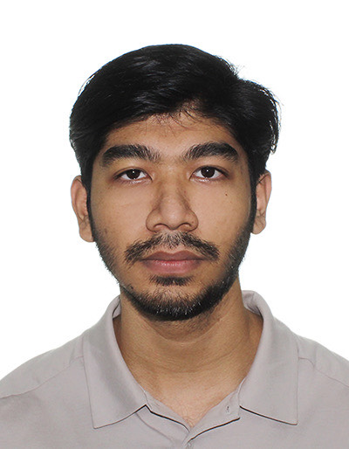
CAREER OBJECTIVE
As a dedicated student working towards a degree in robotics systems, I am enthusiastic and eager to gain valuable industry experience that will enhance my skills and contribute to my professional growth
If given the chance, I am keen to learn and deepen my knowledge in the technical field of engineering to become a competent and capable engineer in a personal or team setting of an organization.
In the long run, I will be exploring various soft skills from diverse areas such as effective communications, critical thinking, teamwork, work ethics and leadership to facilitate my transition into management function role of an organization.

SOFTWARE SKILLS
- Programming: C,C++,Python, MATLAB​
- Robotics: Robotic Operation System (ROS), SLAM, Gazebo, RViz
- Prototyping: CAD Software (Solidworks, Fusion360,AutoCAD), Eagle
- Systems Engineering/Project Management: Capella MBSE, ProjectLibre
- Others: RapidMiner, Microsoft Office, Microsoft Visual Studios

PERSONAL SKILLS
- Excellent written and verbal communication skills.
- Able to work independently or act as a support in a group.
- Possess strong multi-tasking capability and good teamwork skills.
- Eager to learn new skills and knowledge to develop them.
- Able to manage task flow to complete assignments on time.
- Capable of adapting well in new environments.
- Leadership

EDUCATION
- Diploma in Electronics
Temasek Polytechnic/School of Engineering – (April 2017 to March 2020)

- ‘O’ Level Certification
Ang Mo Kio Secondary School – (January 2012 – December 2016)

- Degree in Robotics Systems Engineering
Singapore Institute of Technology - (August 2023 - Present)

INTERNSHIP
- National Computer Systems Pte Ltd (NCS)
Customer Service Desk Assistant (Oct 2019 to Feb 2020)
- Communicate with users to refer them to proper personnel with resolve their issues.
- Data collection & generate monthly update report.
- Utilizing IT service management system (ITSM).

FINAL YEAR PROJECT
(TP) Objective
- Design and fabricate a highly reliable and user-friendly robotic charger to enable wireless charging for various robots with different power supplies.

Engineering Challenges
- Design and Fabrication of Robotic Charger casing.
- Designing and printing of PCB board using EAGLE software.
- Create programming scripts using MPLAB.

Result: Successfully developed a robotic charger that can simulate a brand-friendly charger that runs smoothly.

NATIONAL SERVICE [May’20 – May’22, Rank: 3rd Sergeant]
- Posted to Specialist Cadet School to serve a Section Trainer to guide cadets on course to be respectable Specialists when they graduate from the course.
- Grooms fresh graduates direct from the Basic Military Training Centre, where they are taught basic infantry skills to command an infantry section and become future leaders of the SAF.
- Obtain a certificate of completion for Trainer Qualification Course, issued by SAF.
- Obtain a certificate of completion of a 2-year national service, issued by Singapore Armed Forces (SAF)

Assistant Maintenance Engineer [June’22-July’23]
- STMicroelectronics
- Systematic troubleshooting and isolation of equipment-related problems to minimize equipment downtime & prevent reoccurrence.
- Working with Equipment Engineer to establish effective preventive maintenance program and troubleshooting guide.
- Training and guiding Junior Assistant Maintenance Engineer and Preventive Maintenance Technician in systematic troubleshooting and preventive maintenance skills.
- Leading and participating in continuous improvement project (CIP) to achieve best in class in Safety, Quality Service and Cost.
- Working closely with shift Process and Production personnel to ensure key performance Indices are met.

